**PATTERN RECOGNITION AND ANOMALY DETECTION LAB FILE**



**Name: Aviral Khanna**

**Sap: 500108516**

**Roll No.: R2142221156**

**Batch: B-3 AI/ML(Hons.) Submitted To: Ms. Pooja Sarin**

## Experiment - 1

### What is Anaconda :

Anaconda is a popular open-source distribution for Python and R, widely used in data science, machine learning, and scientific computing. It simplifies package management and deployment, making it easier to work with large-scale data analysis and AI/ML projects.

### Key Features of Anaconda

* **Package & Environment Management:** Uses conda to manage dependencies and virtual environments.
* **Pre-installed Libraries:** Comes with over 1,500+ scientific packages like NumPy, Pandas, SciPy, and Matplotlib.
* **Jupyter Notebook & Spyder:** Includes tools for interactive coding and visualization.
* **Cross-Platform:** Available for Windows, macOS, and Linux.
* **Optimized for Machine Learning:** Supports deep learning frameworks like TensorFlow, PyTorch, and Scikit-learn.

**Installing Anaconda**



**Set up environment :**

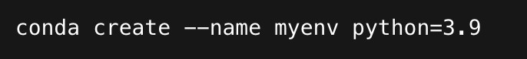



**Install Packages :**

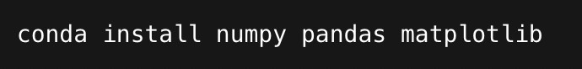

## Experiment - 2

### NumPy:

NumPy (Numerical Python) is a powerful library for numerical computations. It provides support for multi-dimensional arrays and matrices, along with mathematical functions to operate on these data structures efficiently. NumPy arrays are more efficient and faster than Python lists due to their fixed type, memory optimization, and vectorized operations.

### Key Features of NumPy:

* Support for N-dimensional arrays (ndarray).
* Mathematical and statistical functions.
* Linear algebra operations.
* Random number generation.

### Pandas:

Pandas is a widely used data manipulation and analysis library built on top of NumPy. It provides two main data structures:

1. Series – A one-dimensional labeled array capable of holding any data type.
2. DataFrame – A two-dimensional, tabular data structure with labeled axes (rows and columns), similar to a spreadsheet or SQL table.

### Key Features of Pandas:

* + DataFrame and Series for structured data handling.
  + Efficient data selection, filtering, and transformation.

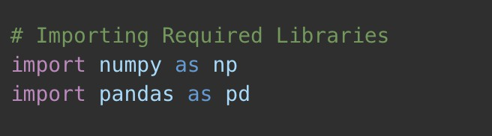

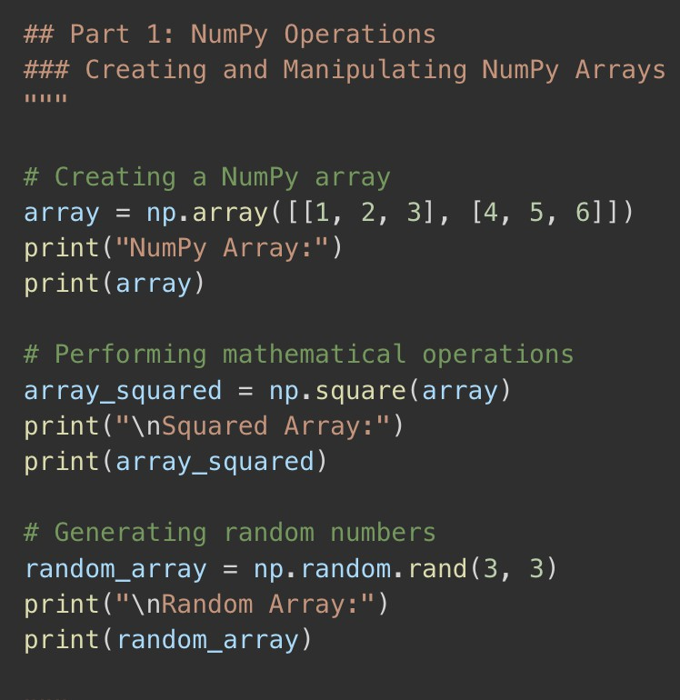

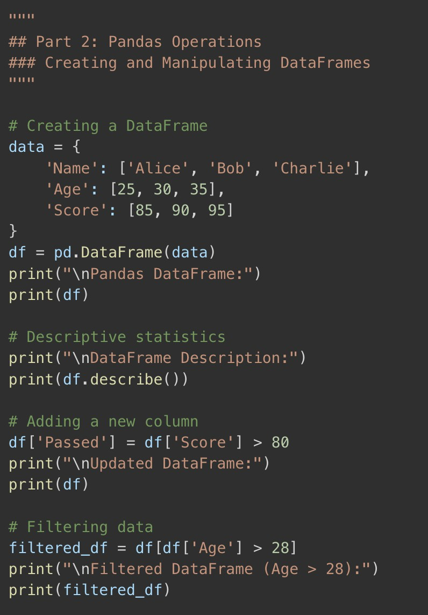

## Experiment - 3

### Linear Regression

Linear Regression is a fundamental statistical and machine learning technique used for modeling the relationship between a dependent variable (target) and one or more independent variables (features). It assumes a linear relationship between the variables and is widely used for prediction and analysis.

1. **Types of Linear Regression**

### Simple Linear Regression:

* + - Involves one independent variable (X) and one dependent variable (Y).
    - The model equation is:

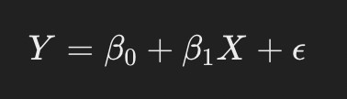

### Multiple Linear Regression:

* + - Extends Simple Linear Regression to multiple independent variables.
    - The model equation is:

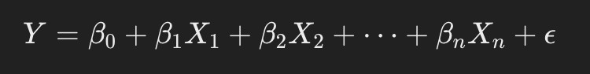

In [1]:

*#linear regression in making*

In [4]:

*# things we can learn in making this*

*# how would i know it right now i just started it*

In [ ]:

In [ ]:

In [49]:

**import** matplotlib.pyplot **as** plt

**import** seaborn **as** sns

**import** plotly.express **as** px

**from** sklearn.compose **import** ColumnTransformer

**from** sklearn.preprocessing **import** OneHotEncoder, StandardScaler

**from** sklearn.ensemble **import** RandomForestRegressor, GradientBoostingRegre

**from** sklearn.metrics **import** mean_squared_error, r2_score

In [2]:

**import** numpy **as** np

**import** pandas **as** pd

# EDA

In [30]:

df **=** pd**.**read_csv("possum.csv") df1 **=** pd**.**read_csv("possum.csv")

In [31]:

df**.**head()

|  |  |  |  |  |  |  |  |  |  |  |  |  |  |
| --- | --- | --- | --- | --- | --- | --- | --- | --- | --- | --- | --- | --- | --- |
| Out[31]: | **c** | **ase** | **site** | **Pop** | **sex** | **age** | **hdlngth** | **skullw** | **totlngth** | **taill** | **footlgth** | **earconch** | **eye** |
|  | **0** | 1 | 1 | Vic | **m** | 8.0 | 94.1 | 60.4 | 89.0 | 36.0 | 74.5 | 54.5 | 15.2 |
|  | **1** | 2 | 1 | Vic | f | 6.0 | 92.5 | 57.6 | 91.5 | 36.5 | 72.5 | 51.2 | 16.0 |
|  | **2** | 3 | 1 | Vic | f | 6.0 | 94.0 | 60.0 | 95.5 | 39.0 | 75.4 | 51.9 | 15.5 |
|  | **3** | 4 | 1 | Vic | f | 6.0 | 93.2 | 57.1 | 92.0 | 38.0 | 76.1 | 52.2 | 15.2 |
|  | **4** | 5 | 1 | Vic | f | 2.0 | 91.5 | 56.3 | 85.5 | 36.0 | 71.0 | 53.2 | 15.1 |

In [32]:

df**.**describe()

|  |  |  |  |  |  |  |  |  |
| --- | --- | --- | --- | --- | --- | --- | --- | --- |
| Out[32]: |  | **case** | **site** | **age** | **hdlngth** | **skullw** | **totlngth** |  |
|  | **count** | 104.000000 | 104.000000 | 102.000000 | 104.000000 | 104.000000 | 104.000000 | 104.00 |
|  | **mean** | 52.500000 | 3.625000 | 3.833333 | 92.602885 | 56.883654 | 87.088462 | 37.00 |
|  | **std** | 30.166206 | 2.349086 | 1.909244 | 3.573349 | 3.113426 | 4.310549 | 1.95 |
|  | **min** | 1.000000 | 1.000000 | 1.000000 | 82.500000 | 50.000000 | 75.000000 | 32.00 |
|  | **25%** | 26.750000 | 1.000000 | 2.250000 | 90.675000 | 54.975000 | 84.000000 | 35.87 |
|  | **50%** | 52.500000 | 3.000000 | 3.000000 | 92.800000 | 56.350000 | 88.000000 | 37.00 |
|  | **75%** | 78.250000 | 6.000000 | 5.000000 | 94.725000 | 58.100000 | 90.000000 | 38.00 |
|  | **max** | 104.000000 | 7.000000 | 9.000000 | 103.100000 | 68.600000 | 96.500000 | 43.00 |

In [33]:

df**.**isna()**.**sum()

|  |  |  |
| --- | --- | --- |
| Out[33]: | case | 0 |
|  | site | 0 |
|  | Pop | 0 |
|  | sex | 0 |
|  | age | 2 |
|  | hdlngth | 0 |
|  | skullw | 0 |
|  | totlngth | 0 |
|  | taill | 0 |
|  | footlgth | 1 |
|  | earconch | 0 |
|  | eye | 0 |
|  | chest | 0 |
|  | belly | 0 |
|  | dtype: int64 |  |

In [7]:

df**.**drop(["case"], inplace**=True**, axis**=**1) *#only a index no need in the data*

In [8]:

categorical_column **=** df**.**select_dtypes(include**=**"object")**.**columns

In [9]:

df **=** df**.**drop(["Pop","sex"], axis**=**1) *# popping out categorical columns and*

In [16]:

numerical_column **=** df**.**select_dtypes(exclude**=**"object")**.**columns print(categorical_column, numerical_column)

Index(['Pop', 'sex'], dtype='object') Index(['site', 'age', 'hdlngth', 'skullw', 'totlngth', 'taill', 'footlgth',

'earconch', 'eye', 'chest', 'belly'], dtype='object')

In [17]:

df**.**describe()

|  |  |  |  |  |  |  |  |  |
| --- | --- | --- | --- | --- | --- | --- | --- | --- |
| Out[17]: |  | **site** | **age** | **hdlngth** | **skullw** | **totlngth** | **taill** | **foo** |
|  | **count** | 104.000000 | 102.000000 | 104.000000 | 104.000000 | 104.000000 | 104.000000 | 103.00 |
|  | **mean** | 3.625000 | 3.833333 | 92.602885 | 56.883654 | 87.088462 | 37.009615 | 68.45 |
|  | **std** | 2.349086 | 1.909244 | 3.573349 | 3.113426 | 4.310549 | 1.959518 | 4.39 |
|  | **min** | 1.000000 | 1.000000 | 82.500000 | 50.000000 | 75.000000 | 32.000000 | 60.30 |
|  | **25%** | 1.000000 | 2.250000 | 90.675000 | 54.975000 | 84.000000 | 35.875000 | 64.60 |
|  | **50%** | 3.000000 | 3.000000 | 92.800000 | 56.350000 | 88.000000 | 37.000000 | 68.00 |
|  | **75%** | 6.000000 | 5.000000 | 94.725000 | 58.100000 | 90.000000 | 38.000000 | 72.50 |
|  | **max** | 7.000000 | 9.000000 | 103.100000 | 68.600000 | 96.500000 | 43.000000 | 77.90 |

In [18]:

df**.**dtypes

Out[18]:

In [19]:

site int64

age float64

hdlngth float64

skullw float64

totlngth float64

taill float64

footlgth float64

earconch float64

eye float64

chest float64

belly float64 dtype: object

df**.**corr()**.**style**.**background_gradient(cmap**=**"coolwarm")

Out[19]:

|  |  |  |  |  |  |  |
| --- | --- | --- | --- | --- | --- | --- |
| **site** | **age** | **hdlngth** | **skullw** | **totlngth** | **taill** | **footlgth** |

|  |  |  |  |  |  |  |  |
| --- | --- | --- | --- | --- | --- | --- | --- |
| **site** | 1.000000 | -0.131423 | -0.163646 | -0.083548 | -0.260843 | 0.380444 | -0.783009 |
| **age** | -0.131423  -0.163646 | 1.000000 | 0.319022 | 0.285107 | 0.260280 | 0.118241 | 0.126190 |
| **hdlngth** | 0.319022 | 1.000000 | 0.710827 | 0.691094 | 0.287429  0.255921 | 0.391605 |
| **skullw** | -0.083548 | 0.285107  0.260280 | 0.710827  0.691094 | 1.000000 | 0.526413 | 0.275059 |
| **totlngth** | -0.260843 | 0.526413 | 1.000000 | 0.565646 | 0.444832 |
| **taill** | 0.380444 | 0.118241  0.126190 | 0.287429 | 0.255921  0.275059 | 0.565646 | 1.000000 | -0.126277 |
| **footlgth** | -0.783009  -0.790716 | 0.391605 | 0.444832 | -0.126277 | 1.000000 |
| **earconch** | 0.053405 | 0.121463 | -0.000537 | 0.154484 | -0.385136 | 0.783050 |
| **eye** | -0.036987 | 0.235553 | 0.347175 | 0.321991 | 0.247786 | 0.198134 | 0.005213 |
| **chest** | -0.345494 | 0.334209  0.354298 | 0.631498 | 0.629737 | 0.577890 | 0.174997 | 0.450590 |
| **belly** | -0.175266 | 0.562663 | 0.451838 | 0.519465 | 0.294493 | 0.302584 |

# from the above correlation matrix findings :

1.earconch and footlength highest relation

|  |  |  |
| --- | --- | --- |
|  | | 1. headlength and skullwidth 2. headlength and totlength |
| In | [20]: | colors**=**["red","blue", "green","orange","black","purple", "brown","pink"," |
|  |  |  |
| In | [21]: | **for** i **in** range(11): |
|  | | plt**.**figure(figsize**=**(5,5)) sns**.**set(style**=**"darkgrid")  sns**.**histplot(df, x**=**df[numerical_column[i]], kde**=True**, color**=**colors[i] plt**.**title(f"Distribution of {numerical_column[i]}")  plt**.**show() |

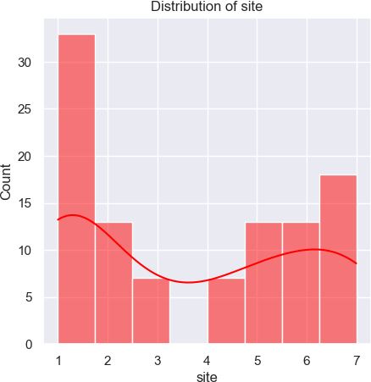

/Users/parz/miniforge3/envs/data-science/lib/python3.9/site-packages/sea born/_oldcore.py:1119: FutureWarning: use_inf_as_na option is deprecated and will be removed in a future version. Convert inf values to NaN befor e operating instead.

with pd.option_context('mode.use_inf_as_na', True):

/Users/parz/miniforge3/envs/data-science/lib/python3.9/site-packages/sea born/_oldcore.py:1119: FutureWarning: use_inf_as_na option is deprecated and will be removed in a future version. Convert inf values to NaN befor e operating instead.

with pd.option_context('mode.use_inf_as_na', True):

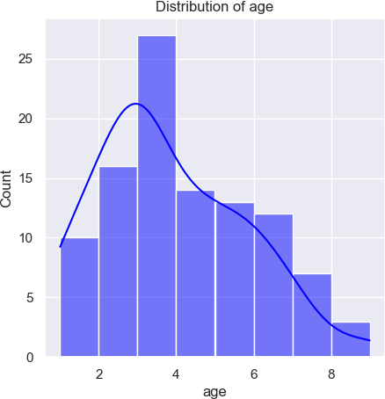

/Users/parz/miniforge3/envs/data-science/lib/python3.9/site-packages/sea born/_oldcore.py:1119: FutureWarning: use_inf_as_na option is deprecated and will be removed in a future version. Convert inf values to NaN befor e operating instead.

with pd.option_context('mode.use_inf_as_na', True):

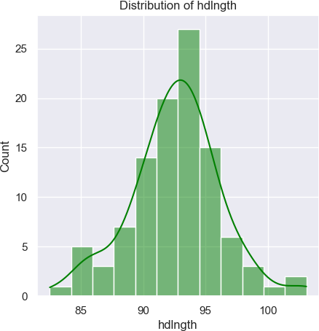

/Users/parz/miniforge3/envs/data-science/lib/python3.9/site-packages/sea born/_oldcore.py:1119: FutureWarning: use_inf_as_na option is deprecated and will be removed in a future version. Convert inf values to NaN befor e operating instead.

with pd.option_context('mode.use_inf_as_na', True):

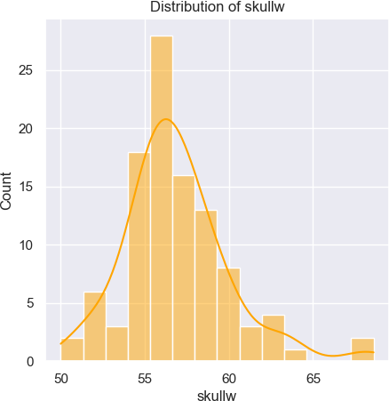

/Users/parz/miniforge3/envs/data-science/lib/python3.9/site-packages/sea born/_oldcore.py:1119: FutureWarning: use_inf_as_na option is deprecated and will be removed in a future version. Convert inf values to NaN befor e operating instead.

with pd.option_context('mode.use_inf_as_na', True):

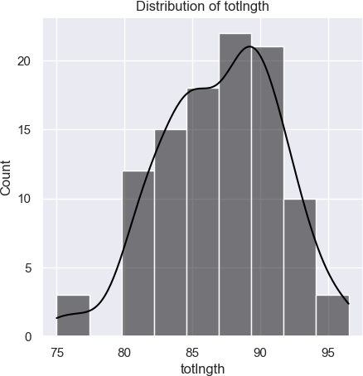

/Users/parz/miniforge3/envs/data-science/lib/python3.9/site-packages/sea born/_oldcore.py:1119: FutureWarning: use_inf_as_na option is deprecated and will be removed in a future version. Convert inf values to NaN befor e operating instead.

with pd.option_context('mode.use_inf_as_na', True):

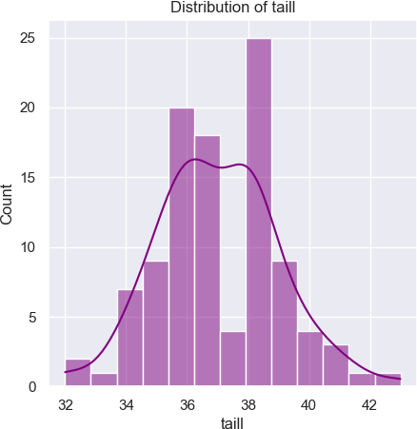

/Users/parz/miniforge3/envs/data-science/lib/python3.9/site-packages/sea born/_oldcore.py:1119: FutureWarning: use_inf_as_na option is deprecated and will be removed in a future version. Convert inf values to NaN befor e operating instead.

with pd.option_context('mode.use_inf_as_na', True):

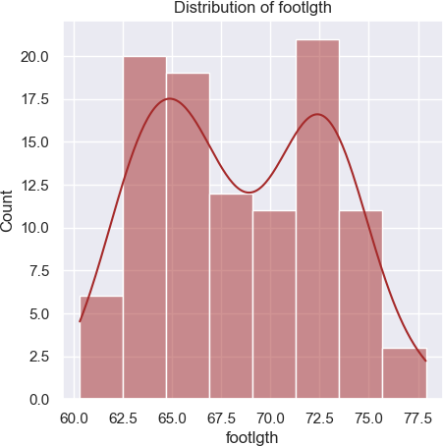

/Users/parz/miniforge3/envs/data-science/lib/python3.9/site-packages/sea born/_oldcore.py:1119: FutureWarning: use_inf_as_na option is deprecated and will be removed in a future version. Convert inf values to NaN befor e operating instead.

with pd.option_context('mode.use_inf_as_na', True):

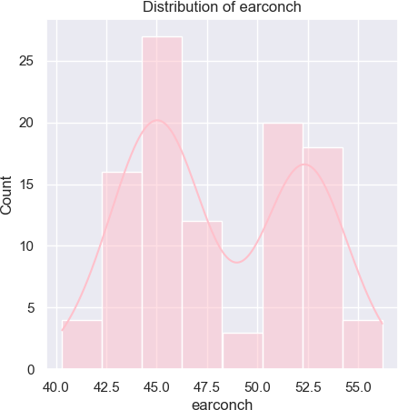

/Users/parz/miniforge3/envs/data-science/lib/python3.9/site-packages/sea born/_oldcore.py:1119: FutureWarning: use_inf_as_na option is deprecated and will be removed in a future version. Convert inf values to NaN befor e operating instead.

with pd.option_context('mode.use_inf_as_na', True):

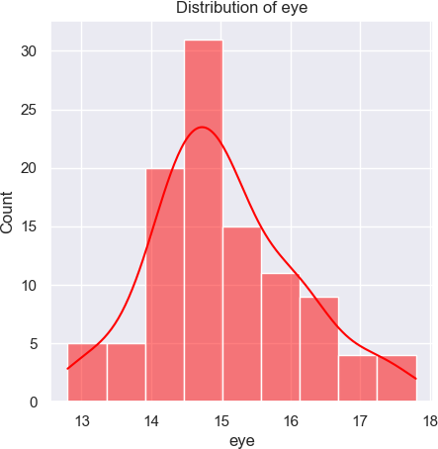

/Users/parz/miniforge3/envs/data-science/lib/python3.9/site-packages/sea born/_oldcore.py:1119: FutureWarning: use_inf_as_na option is deprecated and will be removed in a future version. Convert inf values to NaN befor e operating instead.

with pd.option_context('mode.use_inf_as_na', True):

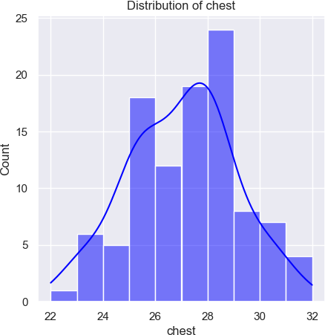

/Users/parz/miniforge3/envs/data-science/lib/python3.9/site-packages/sea born/_oldcore.py:1119: FutureWarning: use_inf_as_na option is deprecated and will be removed in a future version. Convert inf values to NaN befor e operating instead.

with pd.option_context('mode.use_inf_as_na', True):

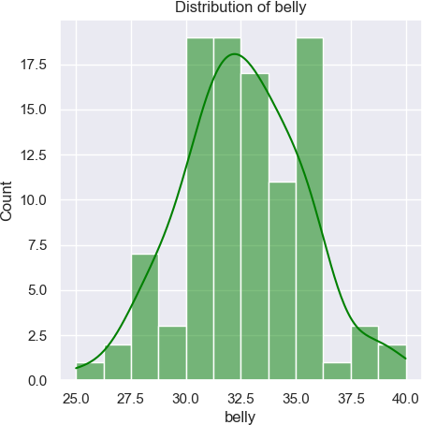

In [23]:

**def** cat_num_feature_selector(dataframe):

cat_features **=** [feature **for** feature **in** dataframe**.**columns **if** df[featur num_features **=** [feature **for** feature **in** dataframe**.**columns **if** df[featur **return** cat_features, num_features

In [24]:

cat, num **=** cat_num_feature_selector(df)

In [25]:

corr_metrix **=** df[num]**.**corr() corr_metrix

|  |  |  |  |  |  |  |  |  |
| --- | --- | --- | --- | --- | --- | --- | --- | --- |
| Out[25]: |  | **site** | **age** | **hdlngth** | **skullw** | **totlngth** | **taill** | **footlgth** |
|  | **site** | 1.000000 | -0.131423 | -0.163646 | -0.083548 | -0.260843 | 0.380444 | -0.783009 |
|  | **age** | -0.131423 | 1.000000 | 0.319022 | 0.285107 | 0.260280 | 0.118241 | 0.126190 |
|  | **hdlngth** | -0.163646 | 0.319022 | 1.000000 | 0.710827 | 0.691094 | 0.287429 | 0.391605 |
|  | **skullw** | -0.083548 | 0.285107 | 0.710827 | 1.000000 | 0.526413 | 0.255921 | 0.275059 |
|  | **totlngth** | -0.260843 | 0.260280 | 0.691094 | 0.526413 | 1.000000 | 0.565646 | 0.444832 |
|  | **taill** | 0.380444 | 0.118241 | 0.287429 | 0.255921 | 0.565646 | 1.000000 | -0.126277 |
|  | **footlgth** | -0.783009 | 0.126190 | 0.391605 | 0.275059 | 0.444832 | -0.126277 | 1.000000 |
|  | **earconch** | -0.790716 | 0.053405 | 0.121463 | -0.000537 | 0.154484 | -0.385136 | 0.783050 |
|  | **eye** | -0.036987 | 0.235553 | 0.347175 | 0.321991 | 0.247786 | 0.198134 | 0.005213 |
|  | **chest** | -0.345494 | 0.334209 | 0.631498 | 0.629737 | 0.577890 | 0.174997 | 0.450590 |
|  | **belly** | -0.175266 | 0.354298 | 0.562663 | 0.451838 | 0.519465 | 0.294493 | 0.302584 |

In [28]:

df**.**columns

Out[28]: Index(['site', 'age', 'hdlngth', 'skullw', 'totlngth', 'taill', 'footlgt h',

'earconch', 'eye', 'chest', 'belly'], dtype='object')

In [43]:

sns**.**scatterplot(data**=**df1, x**=**'skullw', y**=**'hdlngth', hue**=**'sex') plt**.**show()

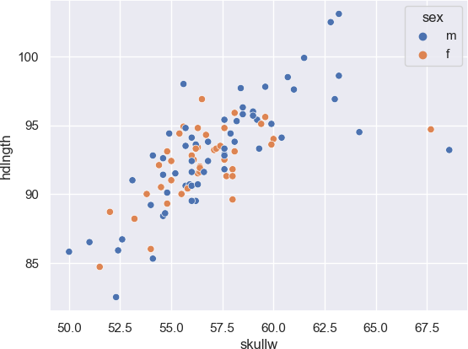

In [44]:

*# split the data into training and for test*

**from** sklearn.model_selection **import** train_test_split

X_train, X_test, y_train, y_test **=** train_test_split(df1**.**drop(columns**=**'hdl

df1['hdlngth'], test_size**=**0.25, random_state**=**42)

X_train**.**shape, X_test**.**shape, y_train**.**shape, y_test**.**shape

Out[44]: ((75, 13), (26, 13), (75,), (26,))

In [45]:

cat, num **=** cat_num_feature_selector(X_train)

In [46]:

transformer **=** ColumnTransformer([ ('encoder', OneHotEncoder(), cat), ('scaler', StandardScaler(), num)

], remainder**=**'passthrough')

X_train_transformed **=** transformer**.**fit_transform(X_train) X_test_transformed **=** transformer**.**transform((X_test))

In [47]:

df1 **=** df1**.**dropna()

In [48]:

model **=** RandomForestRegressor() model**.**fit(X_train_transformed, y_train) y_pred **=** model**.**predict(X_test_transformed)

In [50]:

mse **=** mean_squared_error(y_test, y_pred) rmse **=** (mse)**\*\***0.5

r2 **=** r2_score(y_test, y_pred) print(f"MSE: {mse}")

print(f"RMSE: {rmse}")

print(f"R2 score: {r2}")

MSE: 3.5157507307692266

RMSE: 1.8750335279053616

R2 score: 0.6992377331031833

In [51]:

sns**.**scatterplot(x**=**y_test, y**=**y_pred) plt**.**plot(y_pred, model**.**predict(X_test_transformed)) plt**.**show()

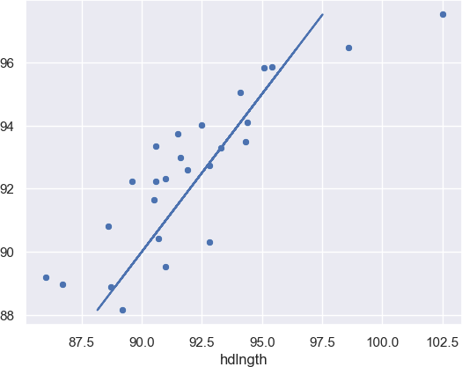

In [52]:

model **=** GradientBoostingRegressor() model**.**fit(X_train_transformed, y_train) y_pred **=** model**.**predict(X_test_transformed)

In [53]:

mse **=** mean_squared_error(y_test, y_pred) rmse **=** (mse)**\*\***0.5

r2 **=** r2_score(y_test, y_pred) print(f"MSE: {mse}")

print(f"RMSE: {rmse}")

print(f"R2 score: {r2}")

MSE: 3.605053581475904

RMSE: 1.8986978647156856

R2 score: 0.6915981335195656

In [54]:

sns**.**scatterplot(x**=**y_test, y**=**y_pred) plt**.**plot(y_pred, model**.**predict(X_test_transformed)) plt**.**show()

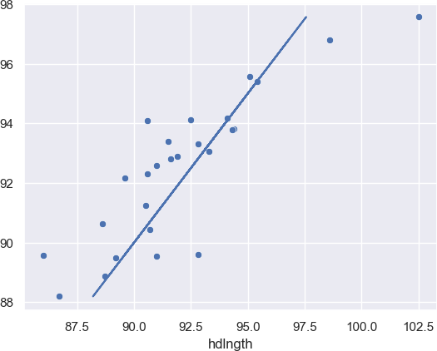

In [ ]:

## Experiment - 4

### Logistic Regression

Logistic Regression is a supervised learning algorithm used for binary and multi-class classification problems. Unlike linear regression, which predicts continuous values, logistic regression predicts probabilities and maps them to discrete classes.

### Sigmoid Function

Logistic regression uses the sigmoid (logistic) function to map input values to a probability range of (0,1):

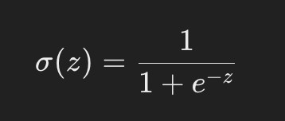

### Variants

* + 1. **Binary Logistic Regression**: Used for two-class classification (e.g., spam vs. not spam).
    2. **Multinomial Logistic Regression**: Used for multi-class classification.
    3. **Ordinal Logistic Regression**: Used for ordered categories.

### Applications

* Email spam classification.
* Credit risk assessment (loan default prediction).

In [12]:

**import** math

**import** numpy **as** np

**import** pandas **as** pd

**import** matplotlib.pyplot **as** plt

**import** seaborn **as** sns **import** plotly.express **as** px **import** pprint

**import** pickle

**import** itertools

In [2]:

df **=** pd**.**read_csv('breast-cancer.csv')

In [3]:

df**.**head()

|  |  |  |  |  |  |  |  |
| --- | --- | --- | --- | --- | --- | --- | --- |
| Out[3]: | **id** | **diagnosis** | **radius_mean** | **texture_mean** | **perimeter_mean** | **area_mean** | **smoo** |
|  | **0** 842302 | M | 17.99 | 10.38 | 122.80 | 1001.0 | |
|  | **1** 842517 | M | 20.57 | 17.77 | 132.90 | 1326.0 | |
|  | **2** 84300903 | M | 19.69 | 21.25 | 130.00 | 1203.0 | |
|  | **3** 84348301 | M | 11.42 | 20.38 | 77.58 | 386.1 | |
|  | **4** 84358402 | M | 20.29 | 14.34 | 135.10 | 1297.0 | |

5 rows × 32 columns

In [4]:

px**.**histogram(data_frame**=**df, x**=**'diagnosis', color**=**'diagnosis',color_discre

350

300

In [5]:

px**.**histogram(data_frame**=**df,x**=**'area_mean',color**=**'diagnosis',color_discrete

100

In [6]:

px**.**histogram(data_frame**=**df,x**=**'perimeter_mean',color**=**'diagnosis',color_dis

70

60

50

In [7]:

px**.**scatter(data_frame**=**df,x**=**'symmetry_worst',color**=**'diagnosis',color_discr

In [8]:

df**.**drop('id', axis**=**1, inplace**=True**) *#redundant columns*

600

500

|  |  |  |
| --- | --- | --- |
|  |  |  |
|  |  |  |



In [9]:

df['diagnosis'] **=** (df['diagnosis'] **==** 'M')**.**astype(int)

In [10]:

corr **=** df**.**corr() plt**.**figure(figsize**=**(20,20)) sns**.**heatmap(corr, cmap**=**'mako_r',annot**=True**) plt**.**show()

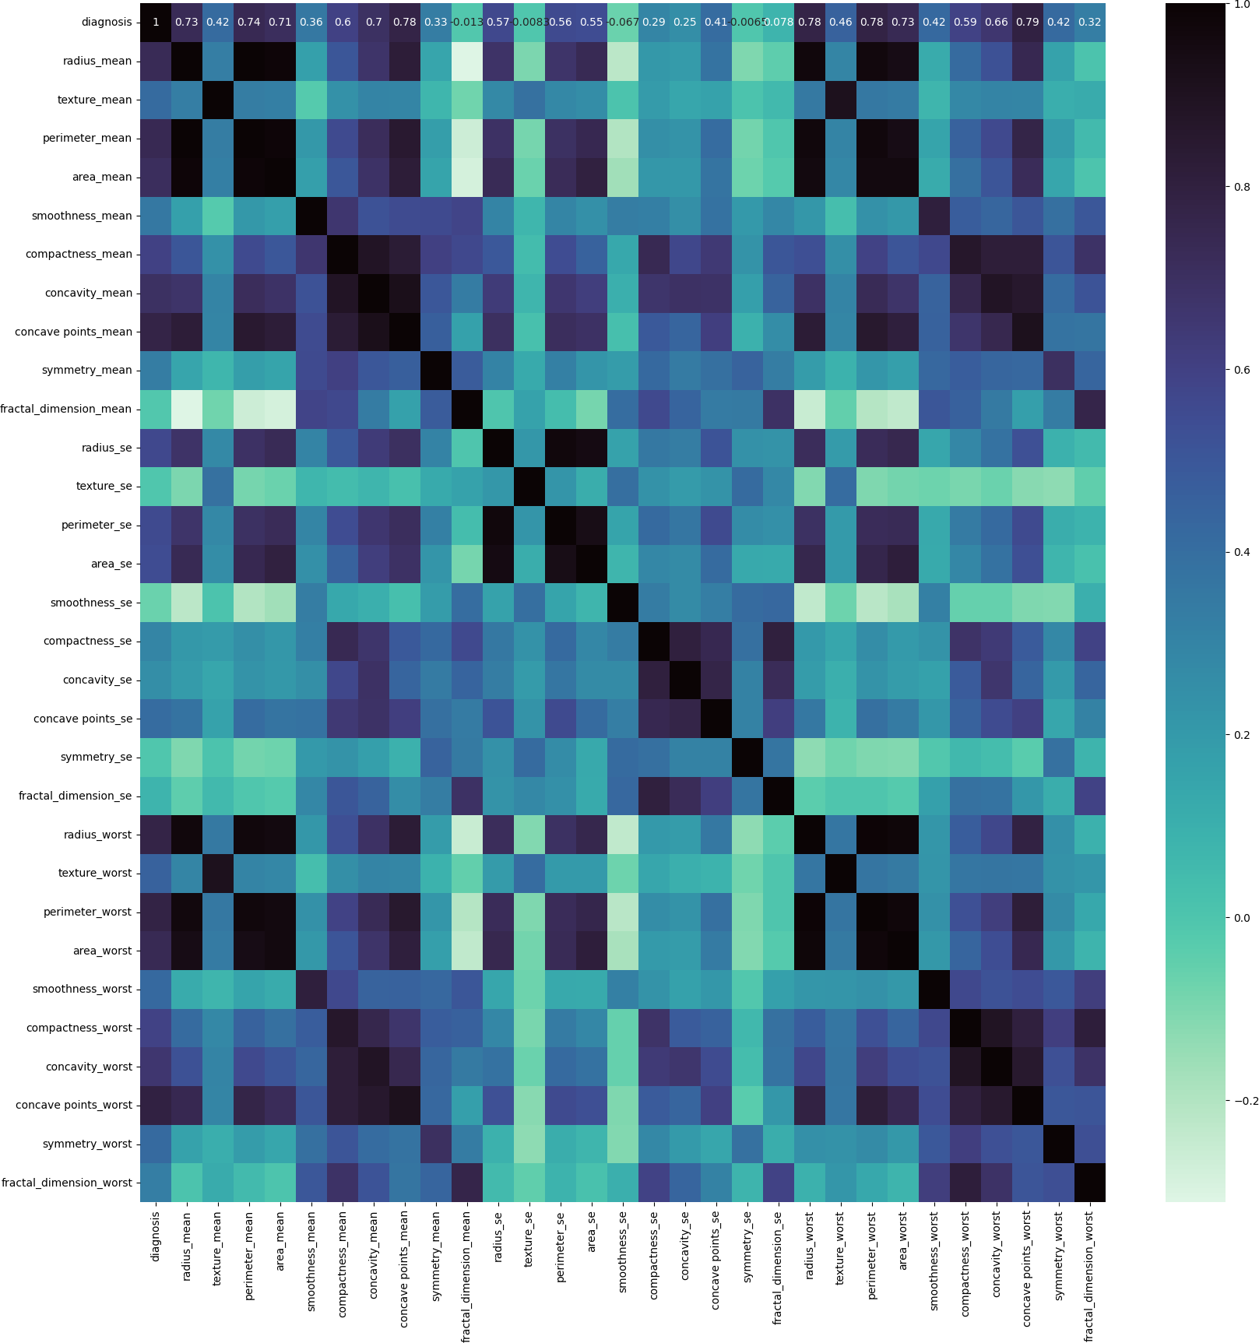

In [14]:

*# Get the absolute value of the correlation*

cor_target **=** abs(corr["diagnosis"])

*# Select highly correlated features (thresold = 0.2)*

relevant_features **=** cor_target[cor_target**>**0.2]

*# Collect the names of the features*

names **=** [index **for** index, value **in** relevant_features**.**items()]

*# Drop the target variable from the results*

names**.**remove('diagnosis')

*# Display the results*

pprint**.**pprint(names)

['radius_mean', 'texture_mean', 'perimeter_mean', 'area_mean', 'smoothness_mean', 'compactness_mean', 'concavity_mean', 'concave points_mean', 'symmetry_mean', 'radius_se', 'perimeter_se', 'area_se', 'compactness_se', 'concavity_se', 'concave points_se', 'radius_worst', 'texture_worst', 'perimeter_worst', 'area_worst', 'smoothness_worst', 'compactness_worst', 'concavity_worst', 'concave points_worst', 'symmetry_worst',

'fractal_dimension_worst']

In [15]:

X **=** df[names]**.**values

y **=** df['diagnosis']**.**values

In [16]:

**def** train_test_split(X, y, random_state**=**42, test_size**=**0.2): """

Splits the data into training and testing sets.

Parameters:

X (numpy.ndarray): Features array of shape (n_samples, n_features y (numpy.ndarray): Target array of shape (n_samples,). random_state (int): Seed for the random number generator. Default test_size (float): Proportion of samples to include in the test s

Returns:

Tuple[numpy.ndarray]: A tuple containing X_train, X_test, y_train

"""

*# Get number of samples*

n_samples **=** X**.**shape[0]

*# Set the seed for the random number generator*

np**.**random**.**seed(random_state)

*# Shuffle the indices*

shuffled_indices **=** np**.**random**.**permutation(np**.**arange(n_samples))

*# Determine the size of the test set*

test_size **=** int(n_samples **\*** test_size)

*# Split the indices into test and train* test_indices **=** shuffled_indices[:test_size] train_indices **=** shuffled_indices[test_size:]

*# Split the features and target arrays into test and train* X_train, X_test **=** X[train_indices], X[test_indices] y_train, y_test **=** y[train_indices], y[test_indices]

**return** X_train, X_test, y_train, y_test

In [17]:

X_train, X_test, y_train, y_test **=** train_test_split(X,y)

In [18]:

**def** standardize_data(X_train, X_test): """

Standardizes the input data using mean and standard deviation.

Parameters:

X_train (numpy.ndarray): Training data. X_test (numpy.ndarray): Testing data.

Returns:

Tuple of standardized training and testing data.

"""

*# Calculate the mean and standard deviation using the training data*

mean **=** np**.**mean(X_train, axis**=**0) std **=** np**.**std(X_train, axis**=**0)

*# Standardize the data*

X_train **=** (X_train **-** mean) **/** std X_test **=** (X_test **-** mean) **/** std

**return** X_train, X_test

X_train, X_test **=** standardize_data(X_train, X_test)

In [19]:

**def** sigmoid(z): """

Compute the sigmoid function for a given input.

The sigmoid function is a mathematical function used in logistic regr to map any real-valued number to a value between 0 and 1.

Parameters:

z (float or numpy.ndarray): The input value(s) for which to compu

Returns:

float or numpy.ndarray: The sigmoid of the input value(s).

Example:

>>> sigmoid(0) 0.5

"""

*# Compute the sigmoid function using the formula: 1 / (1 + e^(-z)).*

sigmoid_result **=** 1 **/** (1 **+** np**.**exp(**-**z))

*# Return the computed sigmoid value.*

**return** sigmoid_result

In [20]:

z **=** np**.**linspace(**-**12, 12, 200)

fig **=** px**.**line(x**=**z, y**=**sigmoid(z),title**=**'Logistic Function',template**=**"plotl fig**.**update_layout(

title_font_color**=**"#41BEE9", xaxis**=**dict(color**=**"#41BEE9"), yaxis**=**dict(color**=**"#41BEE9")

)

fig**.**show()

|  |  |  |  |
| --- | --- | --- | --- |
| 1 | Logistic Function | | |
|  |  |  |
|  |  |  |

In [21]:

**class** LogisticRegression: """

Logistic Regression model.

Parameters:

learning_rate (float): Learning rate for the model.

Methods:

initialize_parameter(): Initializes the parameters of the model. sigmoid(z): Computes the sigmoid activation function for given in forward(X): Computes forward propagation for given input X. compute_cost(predictions): Computes the cost function for given p compute_gradient(predictions): Computes the gradients for the mod fit(X, y, iterations, plot_cost): Trains the model on given input predict(X): Predicts the labels for given input X.

"""

**def**  init (self, learning_rate**=**0.0001): np**.**random**.**seed(1)

self**.**learning_rate **=** learning_rate

**def** initialize_parameter(self): """

Initializes the parameters of the model. """

self**.**W **=** np**.**zeros(self**.**X**.**shape[1]) self**.**b **=** 0.0

**def** forward(self, X): """

Computes forward propagation for given input X.

Parameters:

X (numpy.ndarray): Input array.

Returns:

numpy.ndarray: Output array.

"""

*#print(X.shape, self.W.shape)*

Z **=** np**.**matmul(X, self**.**W) **+** self**.**b A **=** sigmoid(Z)

#### return A

**def** compute_cost(self, predictions): """

Computes the cost function for given predictions.

Parameters:

predictions (numpy.ndarray): Predictions of the model.

Returns:

float: Cost of the model.

"""

m **=** self**.**X**.**shape[0] *# number of training examples*

*# compute the cost*

cost **=** np**.**sum((**-**np**.**log(predictions **+** 1e-8) **\*** self**.**y) **+** (**-**np**.**log(1 1 **-** self**.**y)) *# we are adding small value epsilon to avoi*

cost **=** cost **/** m

**return** cost

**def** compute_gradient(self, predictions): """

Computes the gradients for the model using given predictions.

Parameters:

predictions (numpy.ndarray): Predictions of the model.

"""

*# get training shape*

m **=** self**.**X**.**shape[0]

*# compute gradients*

self**.**dW **=** np**.**matmul(self**.**X**.**T, (predictions **-** self**.**y)) self**.**dW **=** np**.**array([np**.**mean(grad) **for** grad **in** self**.**dW])

self**.**db **=** np**.**sum(np**.**subtract(predictions, self**.**y))

*# scale gradients*

self**.**dW **=** self**.**dW **\*** 1 **/** m self**.**db **=** self**.**db **\*** 1 **/** m

**def** fit(self, X, y, iterations, plot_cost**=True**): """

Trains the model on given input X and labels y for specified iter

Parameters:

X (numpy.ndarray): Input features array of shape (n_samples, y (numpy.ndarray): Labels array of shape (n_samples, 1) iterations (int): Number of iterations for training. plot_cost (bool): Whether to plot cost over iterations or not

Returns:

None.

"""

self**.**X **=** X self**.**y **=** y

self**.**initialize_parameter() costs **=** []

**for** i **in** range(iterations):

*# forward propagation*

predictions **=** self**.**forward(self**.**X)

*# compute cost*

cost **=** self**.**compute_cost(predictions) costs**.**append(cost)

*# compute gradients*

self**.**compute_gradient(predictions)

*# update parameters*

self**.**W **=** self**.**W **-** self**.**learning_rate **\*** self**.**dW self**.**b **=** self**.**b **-** self**.**learning_rate **\*** self**.**db

*# print cost every 100 iterations*

**if** i **%** 10000 **==** 0:

print("Cost after iteration {}: {}"**.**format(i, cost))

**if** plot_cost:

fig **=** px**.**line(y**=**costs,title**=**"Cost vs Iteration",template**=**"plo fig**.**update_layout(

title_font_color**=**"#41BEE9", xaxis**=**dict(color**=**"#41BEE9",title**=**"Iterations"), yaxis**=**dict(color**=**"#41BEE9",title**=**"cost")

)

fig**.**show()

**def** predict(self, X): """

Predicts the labels for given input X.

Parameters:

X (numpy.ndarray): Input features array.

Returns:

numpy.ndarray: Predicted labels.

"""

predictions **=** self**.**forward(X)

**return** np**.**round(predictions)

**def** save_model(self, filename**=None**): """

Save the trained model to a file using pickle.

Parameters:

filename (str): The name of the file to save the model to. """

model_data **=** {

'learning_rate': self**.**learning_rate, 'W': self**.**W,

'b': self**.**b

}

**with** open(filename, 'wb') **as** file: pickle**.**dump(model_data, file)

@classmethod

**def** load_model(cls, filename): """

Load a trained model from a file using pickle.

Parameters:

filename (str): The name of the file to load the model from.

Returns:

LogisticRegression: An instance of the LogisticRegression cla

"""

**with** open(filename, 'rb') **as** file: model_data **=** pickle**.**load(file)

*# Create a new instance of the class and initialize it with the l*

loaded_model **=** cls(model_data['learning_rate']) loaded_model**.**W **=** model_data['W']

loaded_model**.**b **=** model_data['b']

**return** loaded_model

In [22]:

lg **=** LogisticRegression() lg**.**fit(X_train, y_train,100000)

Cost after iteration 0: 0.6931471605599454

Cost after iteration 10000: 0.25707783705582454

Cost after iteration 20000: 0.19529178673689726

Cost after iteration 30000: 0.16685820756163852

Cost after iteration 40000: 0.149789395486765

Cost after iteration 50000: 0.13818761340315544

Cost after iteration 60000: 0.1296814121248933

Cost after iteration 70000: 0.1231144039988139

Cost after iteration 80000: 0.11785163708790082

Cost after iteration 90000: 0.11351377138600201

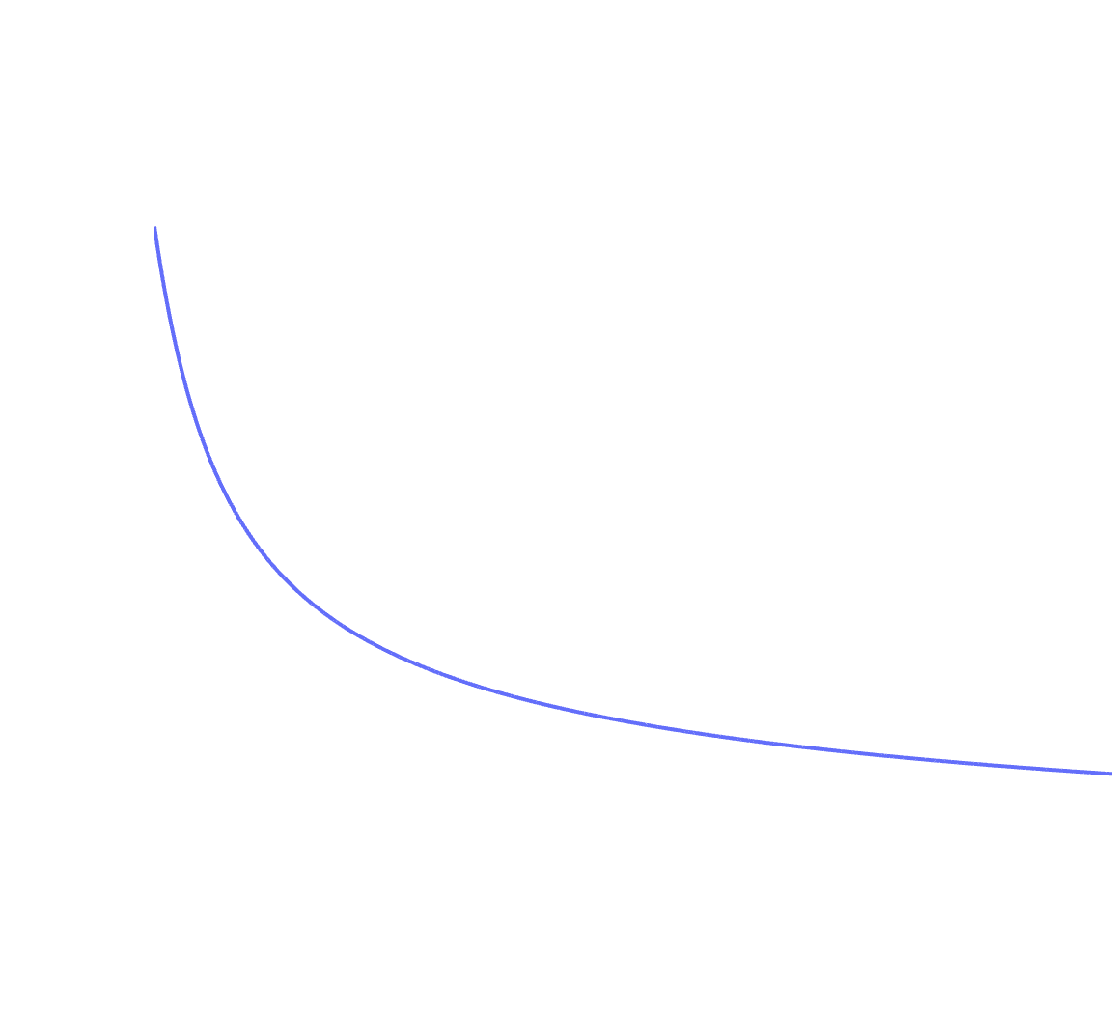

Cost vs Iteration

0.7

0.6

In [ ]:

## Experiment - 5

### Polynomial Regression

Polynomial Regression extends linear regression by introducing polynomial terms to capture non-linearity.

* 1. **Model Equation**

Polynomial regression models a higher-degree relationship:

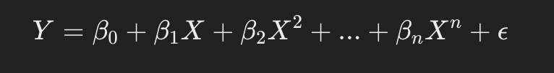

where n is the degree of the polynomial.

* 1. **Key Concepts**
     + **Overfitting**: A high-degree polynomial may fit the training data too closely and generalize poorly.
     + **Underfitting**: A low-degree polynomial may not capture the complexity of the data.
  2. **Selection of Polynomial Degree**

To avoid overfitting or underfitting, techniques like **Cross-Validation** and

**Regularization (Ridge/Lasso)** can be used.

* 1. **Applications**
     + Predicting non-linear trends in financial markets.
     + Estimating complex physical phenomena (e.g., projectile motion).

In [1]:

**import** numpy **as** np

**import** pandas **as** pd

**import** matplotlib.pyplot **as** plt

In [2]:

dataset **=** pd**.**read_csv('Position_Salaries.csv')

In [3]:

dataset**.**head()

|  |  |  |  |  |
| --- | --- | --- | --- | --- |
| Out[3]: |  | **Position** | **Level** | **Salary** |
|  | **0** | Business Analyst | 1 | 45000 |
|  | **1** | Junior Consultant | 2 | 50000 |
|  | **2** | Senior Consultant | 3 | 60000 |
|  | **3** | Manager | 4 | 80000 |
|  | **4** | Country Manager | 5 | 110000 |

In [4]:

*#Dependent feature*

y **=** np**.**asarray(dataset['Salary']**.**values**.**tolist())

*# Independent Feature*

X **=** np**.**asarray(dataset['Level']**.**values**.**tolist())

In [5]:

X **=** X**.**reshape(**-**1,1)

In [6]:

y **=** y**.**reshape(len(y),1) *# Changing the shape from (50,) to (50,1)*

In [7]:

**def** poly_features(features, X):

data **=** pd**.**DataFrame(np**.**zeros((X**.**shape[0],features)))

**for** i **in** range(1,features**+**1): data**.**iloc[:,i**-**1] **=** (X**\*\***i)**.**reshape(**-**1,1)

X_poly **=** np**.**array(data**.**values**.**tolist())

**return** X_poly

In [8]:

**def** split_data(X,y,test_size**=**0.2,random_state**=**0): np**.**random**.**seed(random_state) *#set the seed for repro* indices **=** np**.**random**.**permutation(len(X)) *#shuffling the indices* data_test_size **=** int(X**.**shape[0] **\*** test_size) *#Get the test size*

*#Separating the Independent and Dependent features into the Train and*

train_indices **=** indices[data_test_size:] test_indices **=** indices[:data_test_size] X_train **=** X[train_indices]

y_train **=** y[train_indices] X_test **=** X[test_indices] y_test **=** y[test_indices]

**return** X_train, y_train, X_test, y_test

In [9]:

**def** pred_to_plot(W_trained, X): prediction_values **=** list() **for** i **in** range(X**.**shape[0]):

value **=** regressor**.**predict(W_trained,X[i]) prediction_values**.**append(value)

**return** prediction_values

In [10]:

**class** polynomialRegression():

**def**  init (self):

*#No instance Variables required*

#### pass

**def** forward(self,X,y,W): """

Parameters:

X (array) : Independent Features

y (array) : Dependent Features/ Target Variable W (array) : Weights

Returns:

loss (float) : Calculated Sqaured Error Loss for y and y_pred y_pred (array) : Predicted Target Variable

"""

y_pred **=** sum(W **\*** X)

loss **=** ((y_pred**-**y)**\*\***2)**/**2 *#Loss = Squared Error, we introduce 1/2 f*

**return** loss, y_pred

**def** updateWeights(self,X,y_pred,y_true,W,alpha,index): """

Parameters:

1. (array) : Independent Features

y_pred (array) : Predicted Target Variable

y_true (array) : Dependent Features/ Target Variable W (array) : Weights

alpha (float) : learning rate

index (int) : Index to fetch the corresponding values of W, X and y

Returns:

1. (array) : Update Values of Weight """

**for** i **in** range(X**.**shape[1]):

*#alpha = learning rate, rest of the RHS is derivative of loss funct*

W[i] **-=** (alpha **\*** (y_pred**-**y_true[index])**\***X[index][i])

#### return W

**def** train(self, X, y, epochs**=**10, alpha**=**0.001, random_state**=**0): """

Parameters:

1. (array) : Independent Feature

y (array) : Dependent Features/ Target Variable

epochs (int) : Number of epochs for training, default value is 10 alpha (float) : learning rate, default value is 0.001

Returns:

y_pred (array) : Predicted Target Variable

loss (float) : Calculated Sqaured Error Loss for y and y_pred """

num_rows **=** X**.**shape[0] *#Number of Rows*

num_cols **=** X**.**shape[1] *#Number of Columns*

W **=** np**.**random**.**randn(1,num_cols) **/** np**.**sqrt(num_rows) *#Weight Initializ*

*#Calculating Loss and Updating Weights*

train_loss **=** [] num_epochs **=** []

train_indices **=** [i **for** i **in** range(X**.**shape[0])]

**for** j **in** range(epochs): cost**=**0

np**.**random**.**seed(random_state) np**.**random**.**shuffle(train_indices) **for** i **in** train_indices:

loss, y_pred **=** self**.**forward(X[i],y[i],W[0]) cost**+=**loss

W[0] **=** self**.**updateWeights(X,y_pred,y,W[0],alpha,i) train_loss**.**append(cost)

num_epochs**.**append(j)

**return** W[0], train_loss, num_epochs

**def** test(self, X_test, y_test, W_trained): """

Parameters:

X_test (array) : Independent Features from the Test Set

y_test (array) : Dependent Features/ Target Variable from the Test Se W_trained (array) : Trained Weights

test_indices (list) : Index to fetch the corresponding values of W_tr

X_test and y_test

Returns:

test_pred (list) : Predicted Target Variable

test_loss (list) : Calculated Sqaured Error Loss for y and y_pred """

test_pred **=** [] test_loss **=** []

test_indices **=** [i **for** i **in** range(X_test**.**shape[0])]

**for** i **in** test_indices:

loss, y_test_pred **=** self**.**forward(X_test[i], W_trained, y_test[i]) test_pred**.**append(y_test_pred)

test_loss**.**append(loss)

**return** test_pred, test_loss

**def** predict(self, W_trained, X_sample): prediction **=** sum(W_trained **\*** X_sample) **return** prediction

**def** plotLoss(self, loss, epochs): """

Parameters:

loss (list) : Calculated Sqaured Error Loss for y and y_pred epochs (list): Number of Epochs

Returns: None

Plots a graph of Loss vs Epochs """

plt**.**plot(epochs, loss) plt**.**xlabel('Number of Epochs') plt**.**ylabel('Loss') plt**.**title('Plot Loss') plt**.**show()

In [11]:

X **=** np**.**asarray(dataset['Level']**.**values**.**tolist())

In [12]:

X **=** X**.**reshape(**-**1,1)

|  |  |  |
| --- | --- | --- |
| In [13]: | X |  |
| Out[13]: | array([[ | 1], |
|  | [ | 2], |
|  | [ | 3], |
|  | [ | 4], |
|  | [ | 5], |
|  | [ | 6], |
|  | [ | 7], |
|  | [ | 8], |
|  | [ | 9], |

[10]])

In [14]:

X **=** poly_features(2,X)

/var/folders/lb/_lc8jsw57gg97jlqvd8bn5x80000gn/T/ipykernel_28117/8636191

3.py:4: FutureWarning: Setting an item of incompatible dtype is deprecat ed and will raise in a future error of pandas. Value '[[ 1]

[ 2]

[ 3]

[ 4]

[ 5]

[ 6]

[ 7]

[ 8]

[ 9]

[10]]' has dtype incompatible with float64, please explicitly cast to a compatible dtype first.

data.iloc[:,i-1] = (X**i).reshape(-1,1)

In [15]:

In [16]:

X

*#Adding the feature X0 = 1, so we have the equation: y = W0 + (W1 * X1)*

X **=** np**.**concatenate((X,np**.**ones((10,1))), axis **=** 1)

Out[16]:

In [17]:

array([[ 1., 1., 1.],

[ 2., 4., 1.],

[ 3., 9., 1.],

[ 4., 16., 1.],

[ 5., 25., 1.],

[ 6., 36., 1.],

[ 7., 49., 1.],

[ 8., 64., 1.],

[ 9., 81., 1.],

[ 10., 100., 1.]])

y

Out[17]:

array([[ 45000],

[ 50000],

[ 60000],

[ 80000],

[ 110000],

[ 150000],

[ 200000],

[ 300000],

[ 500000],

[1000000]])

In [24]:

X_train, y_train, X_test, y_test **=** split_data(X,y)

In [25]:

regressor **=** polynomialRegression()

In [28]:

W_trained, train_loss, num_epochs **=** regressor**.**train(X_train, y_train, epo

In [29]:

test_pred, test_loss **=** regressor**.**test(X_test, y_test, W_trained)

In [30]:

pred_plot **=** pred_to_plot(W_trained,X)

In [31]:

plt**.**scatter(X[:,0], y, color **=** 'red') plt**.**plot(X[:,0], pred_plot, color **=** 'blue') plt**.**title('Naive Polynomial Regression (N = 2)') plt**.**xlabel('Position level') plt**.**ylabel('Salary')

plt**.**show()

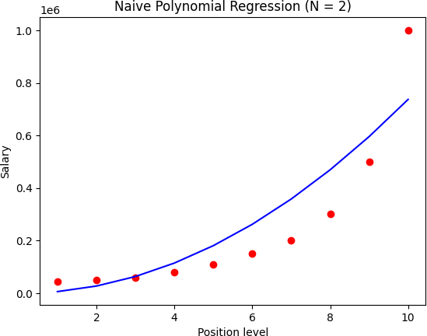

In [32]:

X **=** np**.**asarray(dataset['Level']**.**values**.**tolist())

In [33]:

X **=** X**.**reshape(**-**1,1)

In [34]:

X_poly **=** poly_features(4,X)

/var/folders/lb/_lc8jsw57gg97jlqvd8bn5x80000gn/T/ipykernel_28117/8636191

3.py:4: FutureWarning: Setting an item of incompatible dtype is deprecat ed and will raise in a future error of pandas. Value '[[ 1]

[ 2]

[ 3]

[ 4]

[ 5]

[ 6]

[ 7]

[ 8]

[ 9]

[10]]' has dtype incompatible with float64, please explicitly cast to a compatible dtype first.

data.iloc[:,i-1] = (X**i).reshape(-1,1)

In [35]:

X_poly **=** np**.**concatenate((X_poly,np**.**ones((10,1))), axis **=** 1)

In [36]:

X_poly

|  |  |  |  |  |  |  |  |
| --- | --- | --- | --- | --- | --- | --- | --- |
| Out[36]: | | array([[1.000e+00,  [2.000e+00, [3.000e+00, [4.000e+00, [5.000e+00, [6.000e+00, [7.000e+00, [8.000e+00, [9.000e+00,  [1.000e+01, | | 1.000e+00,  4.000e+00,  9.000e+00,  1.600e+01,  2.500e+01,  3.600e+01,  4.900e+01,  6.400e+01,  8.100e+01,  1.000e+02, | 1.000e+00,  8.000e+00,  2.700e+01,  6.400e+01,  1.250e+02,  2.160e+02,  3.430e+02,  5.120e+02,  7.290e+02,  1.000e+03, | 1.000e+00,  1.600e+01,  8.100e+01,  2.560e+02,  6.250e+02,  1.296e+03,  2.401e+03,  4.096e+03,  6.561e+03,  1.000e+04, | 1.000e+00],  1.000e+00],  1.000e+00],  1.000e+00],  1.000e+00],  1.000e+00],  1.000e+00],  1.000e+00],  1.000e+00],  1.000e+00]]) |
| In [37]: | | y | | | | | |
| Out[37]: | | array([[ | 45000], | | | | |
|  | | [ | 50000], | | | | |
|  | | [ | 60000], | | | | |
|  | | [ | 80000], | | | | |
|  | | [ | 110000], | | | | |
|  | | [ | 150000], | | | | |
|  | | [ | 200000], | | | | |
|  | | [ | 300000], | | | | |
|  | | [ 500000],  [1000000]]) | | | | | |
| In | [38]: | X_train, y_train, X_test, y_test **=** split_data(X_poly,y) | | | | | |
|  |  |  | | | | | |
| In | [39]: | regressor **=** polynomialRegression() | | | | | |
|  |  |  | | | | | |
| In | [40]: | W_trained, train_loss, num_epochs **=** regressor**.**train(X_train, y_train, epo | | | | | |
|  |  |  | | | | | |
| In | [41]: | test_pred, test_loss **=** regressor**.**test(X_test, y_test, W_trained) | | | | | |
|  |  |  | | | | | |
| In | [42]: | X_poly | | | | | |

|  |  |  |  |  |  |
| --- | --- | --- | --- | --- | --- |
| Out[42]: | array([[1.000e+00, | 1.000e+00, | 1.000e+00, | 1.000e+00, | 1.000e+00], |
|  | [2.000e+00, | 4.000e+00, | 8.000e+00, | 1.600e+01, | 1.000e+00], |
|  | [3.000e+00, | 9.000e+00, | 2.700e+01, | 8.100e+01, | 1.000e+00], |
|  | [4.000e+00, | 1.600e+01, | 6.400e+01, | 2.560e+02, | 1.000e+00], |
|  | [5.000e+00, | 2.500e+01, | 1.250e+02, | 6.250e+02, | 1.000e+00], |
|  | [6.000e+00, | 3.600e+01, | 2.160e+02, | 1.296e+03, | 1.000e+00], |
|  | [7.000e+00, | 4.900e+01, | 3.430e+02, | 2.401e+03, | 1.000e+00], |
|  | [8.000e+00, | 6.400e+01, | 5.120e+02, | 4.096e+03, | 1.000e+00], |
|  | [9.000e+00, | 8.100e+01, | 7.290e+02, | 6.561e+03, | 1.000e+00], |
|  | [1.000e+01, | 1.000e+02, | 1.000e+03, | 1.000e+04, | 1.000e+00]]) |

In [43]:

pred_plot **=** pred_to_plot(W_trained,X_poly)

In [44]:

pred_plot

Out[44]:

In [45]:

[101.56686988148302,

1570.332736753576,

7876.252690310476,

24783.645533405484,

60351.39230382515,

124932.93627428928,

231176.28295245094,

394024.0000808964,

630713.2176371454,

960775.6278336504]

plt**.**scatter(X_poly[:,0], y, color **=** 'red') plt**.**plot(X_poly[:,0], pred_plot, color **=** 'blue') plt**.**title('Naive Polynomial Regression (N=4)') plt**.**xlabel('Position level') plt**.**ylabel('Salary')

plt**.**show()

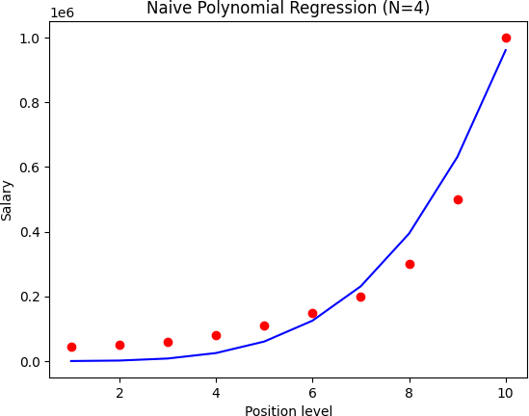

In [46]:

**from** sklearn.model_selection **import** train_test_split **from** sklearn.linear_model **import** LinearRegression **from** sklearn.preprocessing **import** PolynomialFeatures

In [47]:

X_sk **=** dataset**.**iloc[:, 1]**.**values y_sk **=** dataset**.**iloc[:, **-**1]**.**values

In [48]:

X_sk **=** X_sk**.**reshape(**-**1,1) y_sk **=** y_sk**.**reshape(**-**1,1)

In [49]:

*# Constructing the polynomials of our Independent features*

poly_reg **=** PolynomialFeatures(degree **=** 4) X_poly_sk **=** poly_reg**.**fit_transform(X_sk)

In [50]:

*#Get the shapes of X and y*

print("The shape of the independent fatures are ",X_poly_sk**.**shape) print("The shape of the dependent fatures are ",y_sk**.**shape)

The shape of the independent fatures are (10, 5) The shape of the dependent fatures are (10, 1)

In [51]:

X_poly_sk

|  |  |  |  |  |  |
| --- | --- | --- | --- | --- | --- |
| Out[51]: | array([[1.000e+00, | 1.000e+00, | 1.000e+00, | 1.000e+00, | 1.000e+00], |
|  | [1.000e+00, | 2.000e+00, | 4.000e+00, | 8.000e+00, | 1.600e+01], |
|  | [1.000e+00, | 3.000e+00, | 9.000e+00, | 2.700e+01, | 8.100e+01], |
|  | [1.000e+00, | 4.000e+00, | 1.600e+01, | 6.400e+01, | 2.560e+02], |
|  | [1.000e+00, | 5.000e+00, | 2.500e+01, | 1.250e+02, | 6.250e+02], |
|  | [1.000e+00, | 6.000e+00, | 3.600e+01, | 2.160e+02, | 1.296e+03], |
|  | [1.000e+00, | 7.000e+00, | 4.900e+01, | 3.430e+02, | 2.401e+03], |
|  | [1.000e+00, | 8.000e+00, | 6.400e+01, | 5.120e+02, | 4.096e+03], |
|  | [1.000e+00, | 9.000e+00, | 8.100e+01, | 7.290e+02, | 6.561e+03], |
|  | [1.000e+00, | 1.000e+01, | 1.000e+02, | 1.000e+03, | 1.000e+04]]) |

In [52]:

X_train_sk, X_test_sk, y_train_sk, y_test_sk **=** train_test_split(X_poly_sk

In [53]:

regressor_sk **=** LinearRegression() regressor_sk**.**fit(X_train_sk, y_train_sk)

Out[53]:



▾ LinearRegression

LinearRegression()

In [54]:

plt**.**scatter(X_poly_sk[:,1], y, color **=** 'red')

plt**.**plot(X_poly_sk[:,1], regressor_sk**.**predict(X_poly_sk), color **=** 'blue') plt**.**title('Sklearn regression')

plt**.**xlabel('Position level') plt**.**ylabel('Salary') plt**.**show()

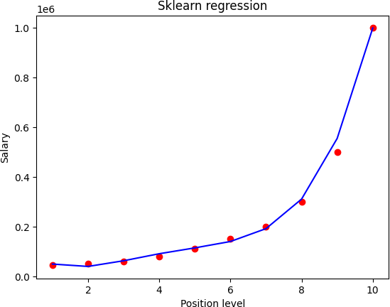

In [ ]:

## Experiment - 6

### Support Vector Machine (SVM)

SVM is a powerful supervised learning algorithm used for classification and regression.

1. **Objective of SVM**

SVM aims to find a **hyperplane** that best separates data into different classes by maximizing the **margin** between the nearest points of different classes.

1. **Key Components**
   * **Hyperplane**: The decision boundary that separates classes.
   * **Support Vectors**: Data points closest to the hyperplane that influence its position.
   * **Margin**: The distance between the hyperplane and the nearest support vectors.
2. **Types of SVM**

**Linear SVM**:

* Used when data is linearly separable.
* The decision function is:

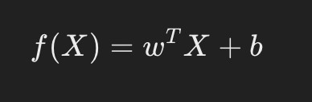

In [1]:

**import** numpy **as** np **import** pandas **as** pd **import** random

**import** matplotlib.pyplot **as** plt

**from** sklearn.datasets **import** make_blobs, make_moons, make_circles

**from** sklearn.metrics **import** mean_squared_error

**from** sklearn.svm **import** SVC

**from** sklearn.model_selection **import** train_test_split

**from** sklearn.metrics **import** accuracy_score

In [2]:

X1, y1 **=** make_blobs(n_samples**=**200, centers**=**2,random_state**=**0, cluster_std**=** y1 **=** np**.**where(y1 **<=** 0, **-**1, 1)

print("First five rows and col values \nX1 : \n",X1[:5], " \n y1 :\n",y1[ plt**.**scatter(X1[:, 0], X1[:, 1], c**=**y1, s**=**50, cmap**=**'winter', alpha**=**.5) plt**.**title("Dataset 1")

plt**.**show()

In [3]:

**class** SVM_soft_margin:

**def**  init (self, alpha **=** 0.001, lambda_ **=** 0.01, n_iterations **=** 1000 self**.**alpha **=** alpha *# learning rate*

self**.**lambda_ **=** lambda_ *# tradeoff*

self**.**n_iterations **=** n_iterations *# number of iterations*

First five rows and col values X1 :

[[2.51526543 1.11143935]

|  |  |  |
| --- | --- | --- |
| [1.8155981 |  | 1.11969719] |
| [2.69637316 |  | 0.62563218] |
| [1.67280531 |  | 0.65930057] |
| [1.89593761 |  | 5.18540259]] |
| y1 : |  |  |
| [ 1 1 1 | 1 | -1] |

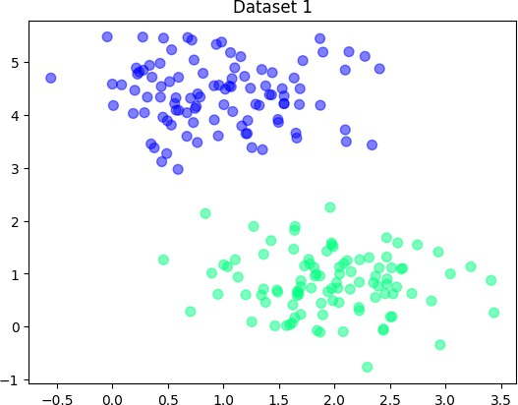

self**.**w **= None** *# weights or slopes*

self**.**b **= None** *# intercept*

**def** fit(self, X, y):

n_samples, n_features **=** X**.**shape

self**.**w **=** np**.**zeros(n_features) *# initalizing with 0*

self**.**b **=** 0 *# initializewith 0*

**for** iteration **in** range(self**.**n_iterations):

**for** i, Xi **in** enumerate(X):

*# yixiw-b≥1*

**if** y[i] **\*** (np**.**dot(Xi, self**.**w) **-** self**.**b) **>=** 1 :

self**.**w **-=** self**.**alpha **\*** (2 **\*** self**.**lambda_ **\*** self**.**w) *#*

**else**:

self**.**w **-=** self**.**alpha **\*** (2 **\*** self**.**lambda_ **\*** self**.**w **-** n self**.**b **-=** self**.**alpha **\*** y[i] *# b = b - α* (yi)*

**return** self**.**w, self**.**b

**def** predict(self, X):

pred **=** np**.**dot(X, self**.**w) **-** self**.**b

result **=** [1 **if** val **>** 0 **else -**1 **for** val **in** pred] *# returning in th*

**return** result

In [4]:

**def** get_hyperplane(x, w, b, offset):

**return** (**-**w[0] **\*** x **+** b **+** offset) **/** w[1]

In [5]:

**def** plot_svm(X, y, w, b, title **=**'Plot for linear SVM'):

fig **=** plt**.**figure()

ax **=** fig**.**add_subplot(1,1,1) plt**.**scatter(X[:,0], X[:,1], marker**=**'o',c**=**y)

x0_1 **=** np**.**amin(X[:,0])

x0_2 **=** np**.**amax(X[:,0])

x1_1 **=** get_hyperplane(x0_1, w, b, 0) x1_2 **=** get_hyperplane(x0_2, w, b, 0)

x1_1_m **=** get_hyperplane(x0_1, w, b, **-**1) x1_2_m **=** get_hyperplane(x0_2, w, b, **-**1)

x1_1_p **=** get_hyperplane(x0_1, w, b, 1) x1_2_p **=** get_hyperplane(x0_2, w, b, 1)

ax**.**plot([x0_1, x0_2],[x1_1, x1_2], 'y--')

ax**.**plot([x0_1, x0_2],[x1_1_m, x1_2_m], 'k')

ax**.**plot([x0_1, x0_2],[x1_1_p, x1_2_p], 'k')

x1_min **=** np**.**amin(X[:,1])

x1_max **=** np**.**amax(X[:,1]) ax**.**set_ylim([x1_min**-**3,x1_max**+**3])

plt**.**title(title) plt**.**show()

In [6]:

svm1 **=** SVM_soft_margin() w1,b1 **=** svm1**.**fit(X1,y1)

print("For dataset 1, score:" ,accuracy_score(svm1**.**predict(X1),y1)) plot_svm(X1, y1, w1, b1, title**=** 'Linear SVM for dataset 1')

For dataset 1, score: 1.0

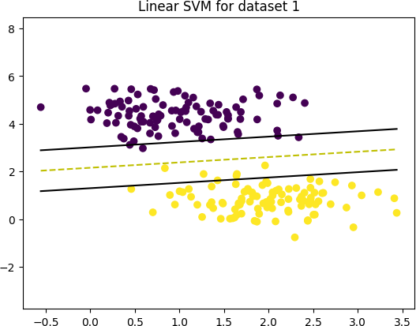

In [ ]: